**Analyze Your Dataset**

1. **How can we predict a listing’s price and correlation with neighborhood or property type?**

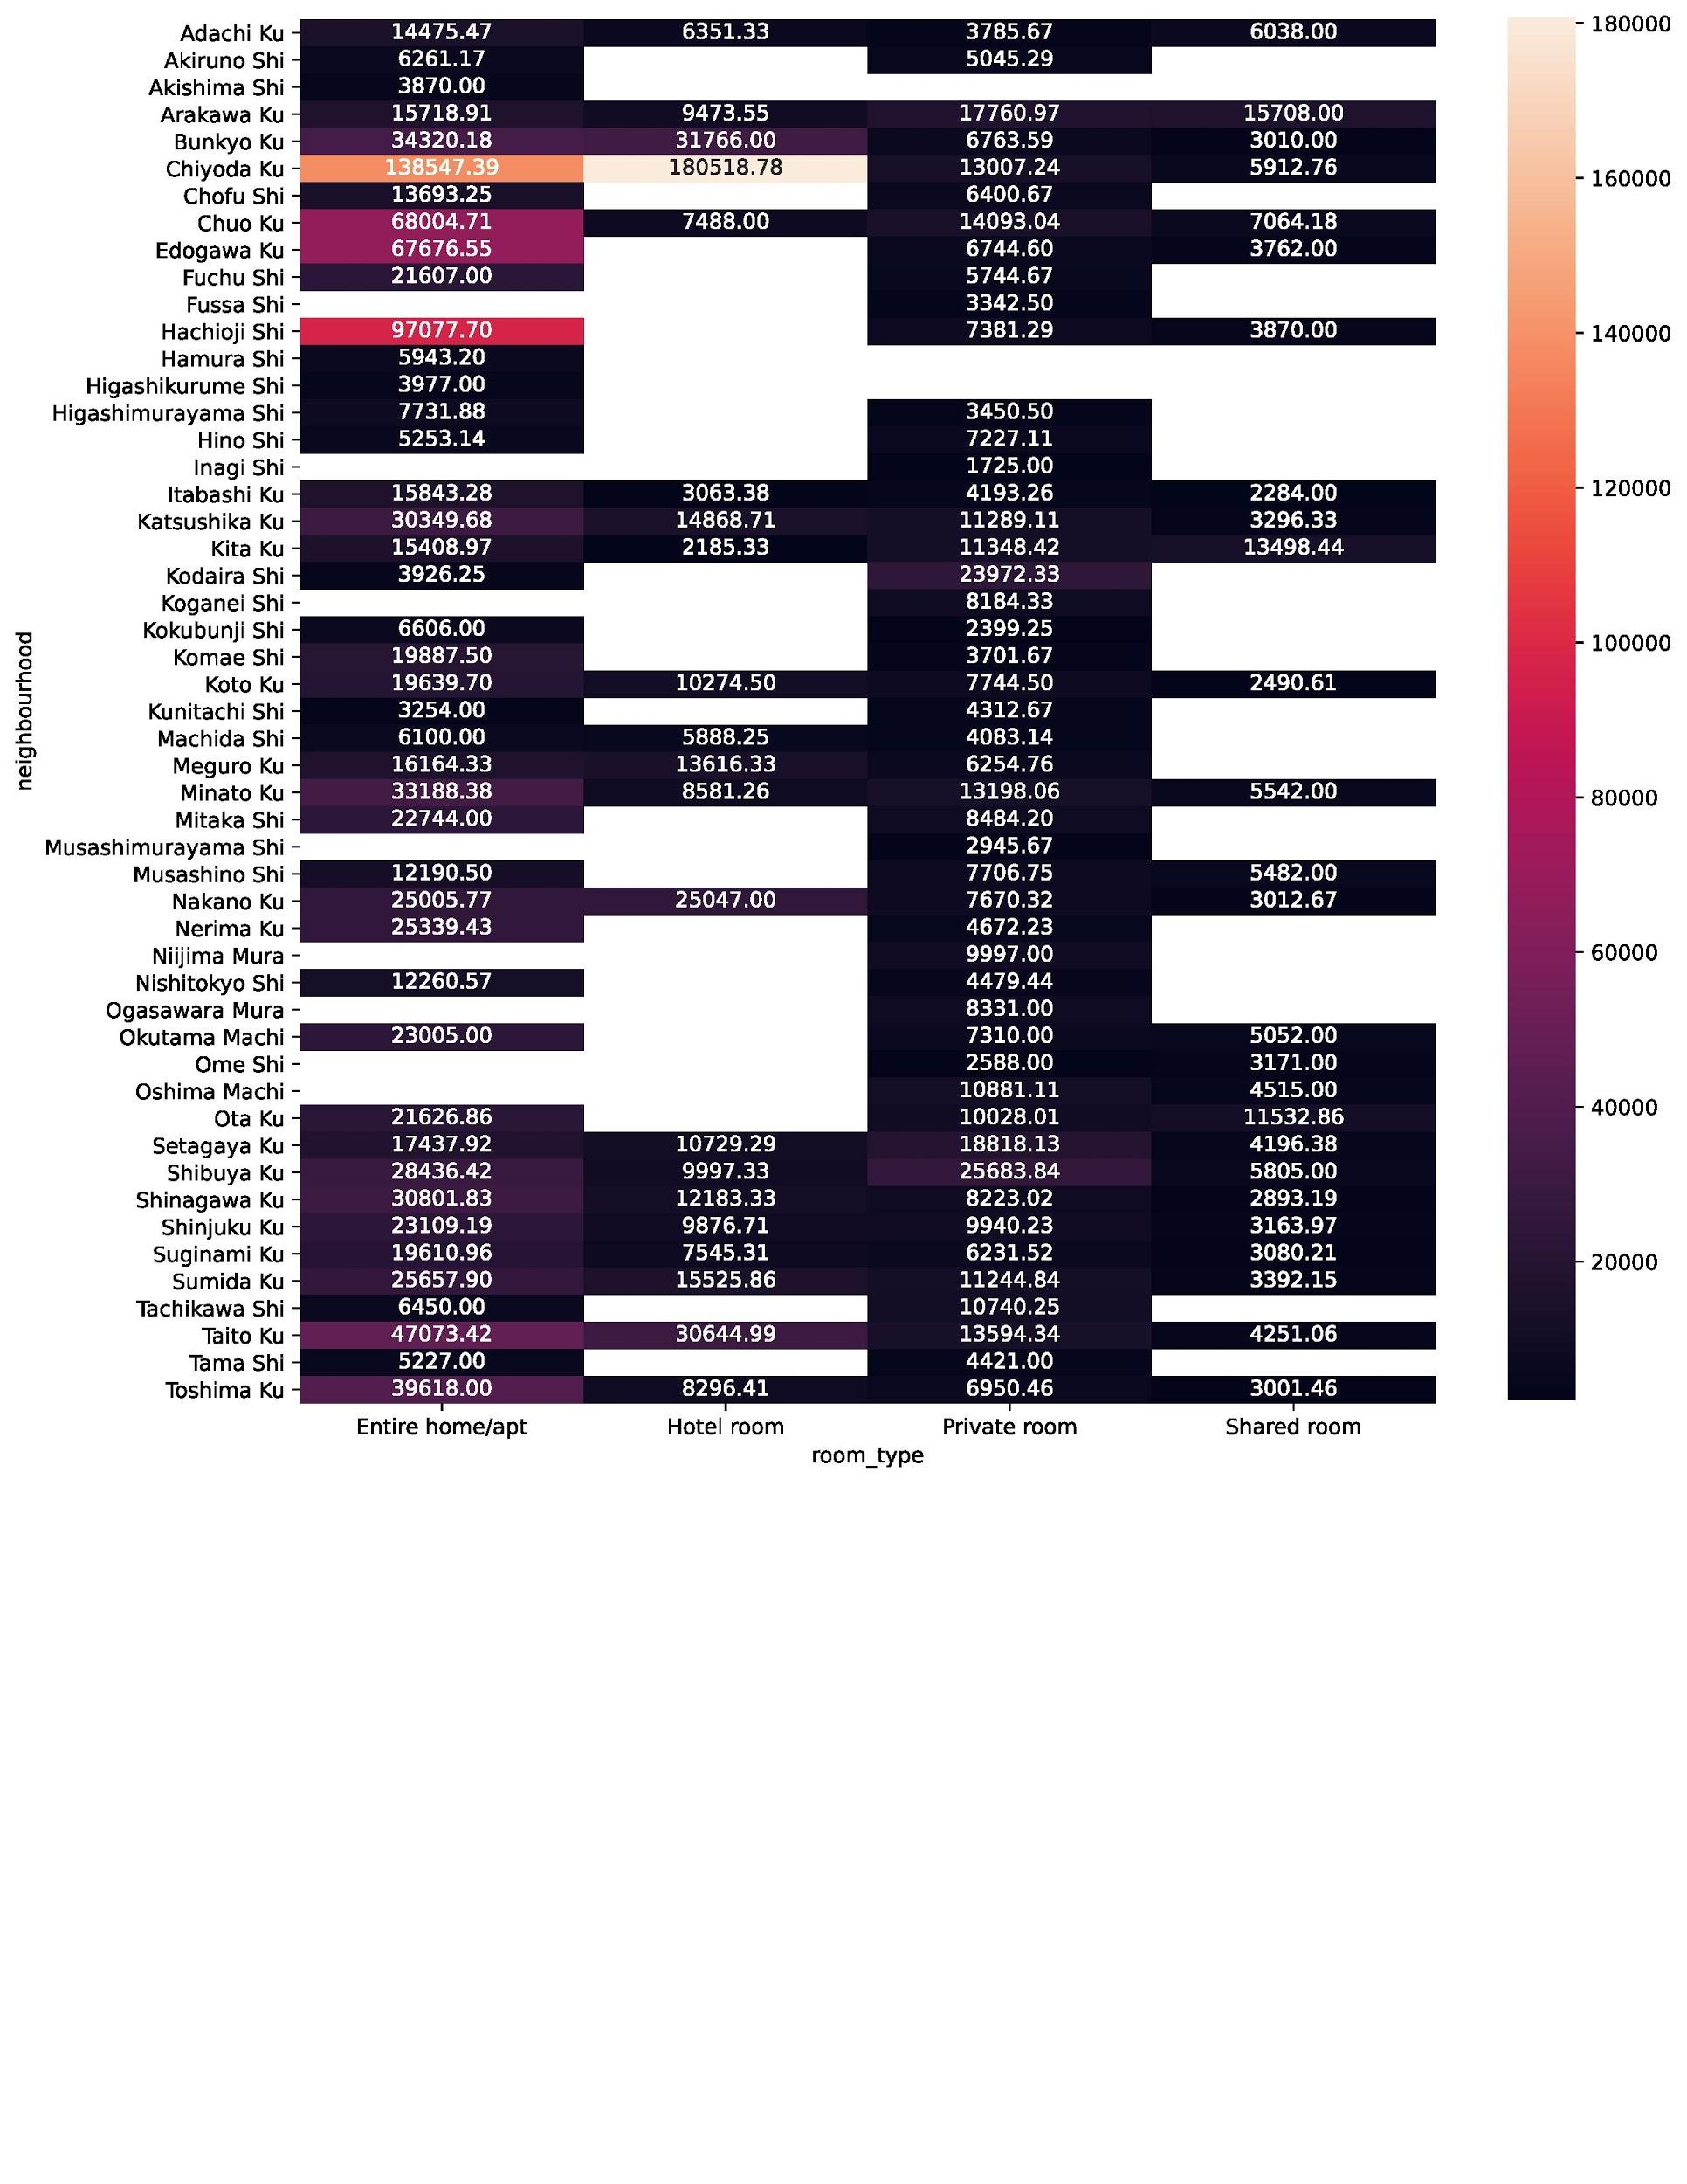

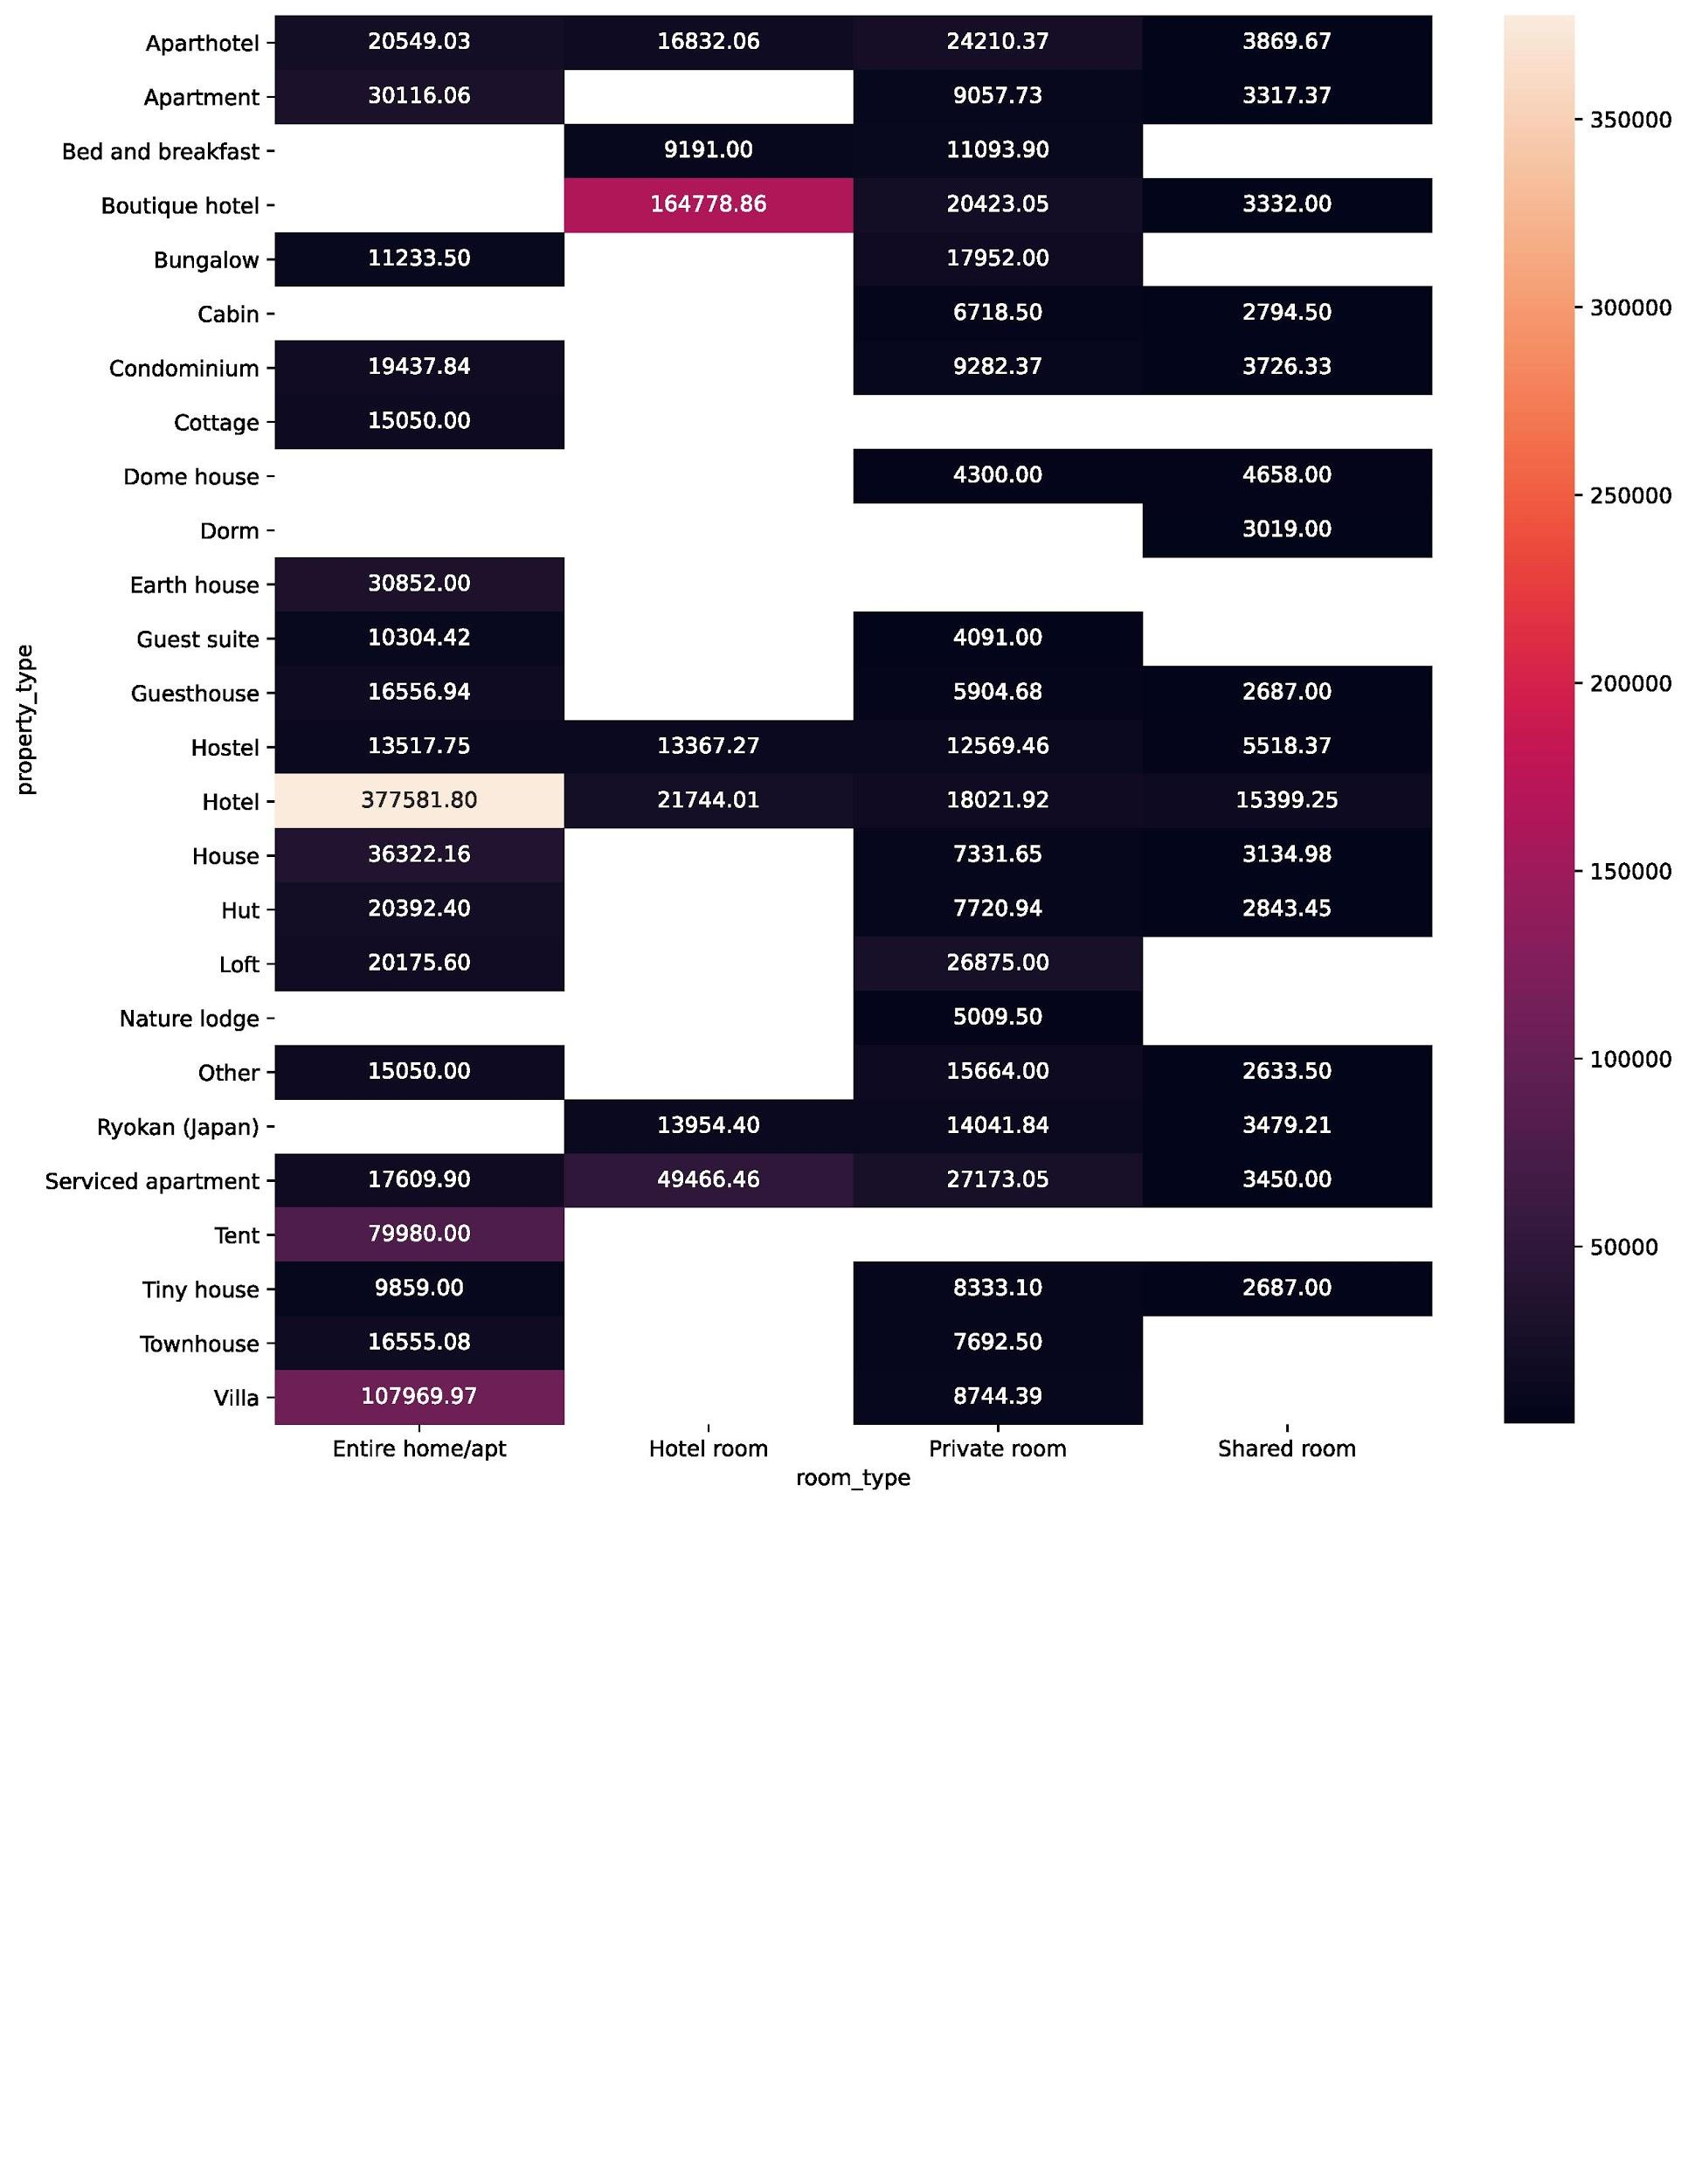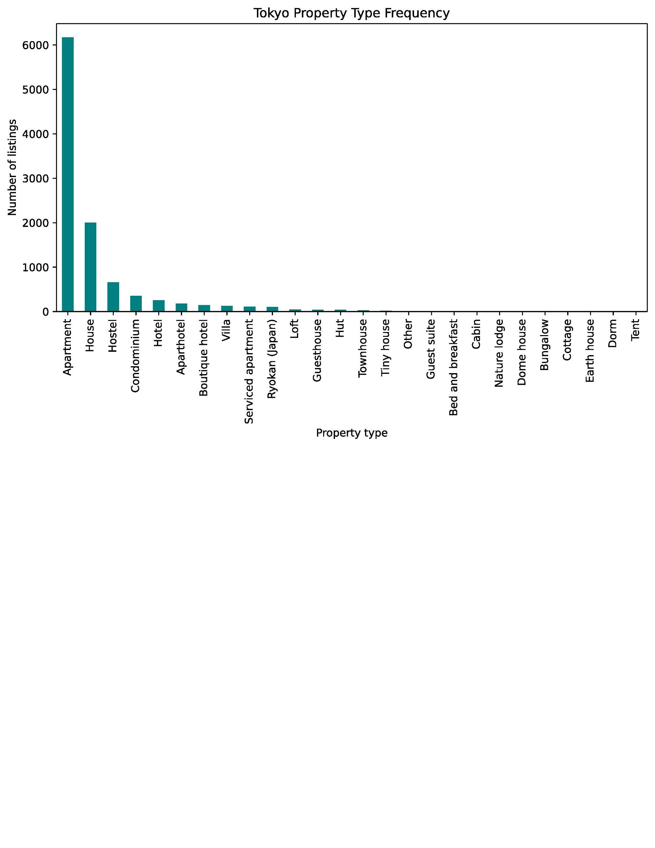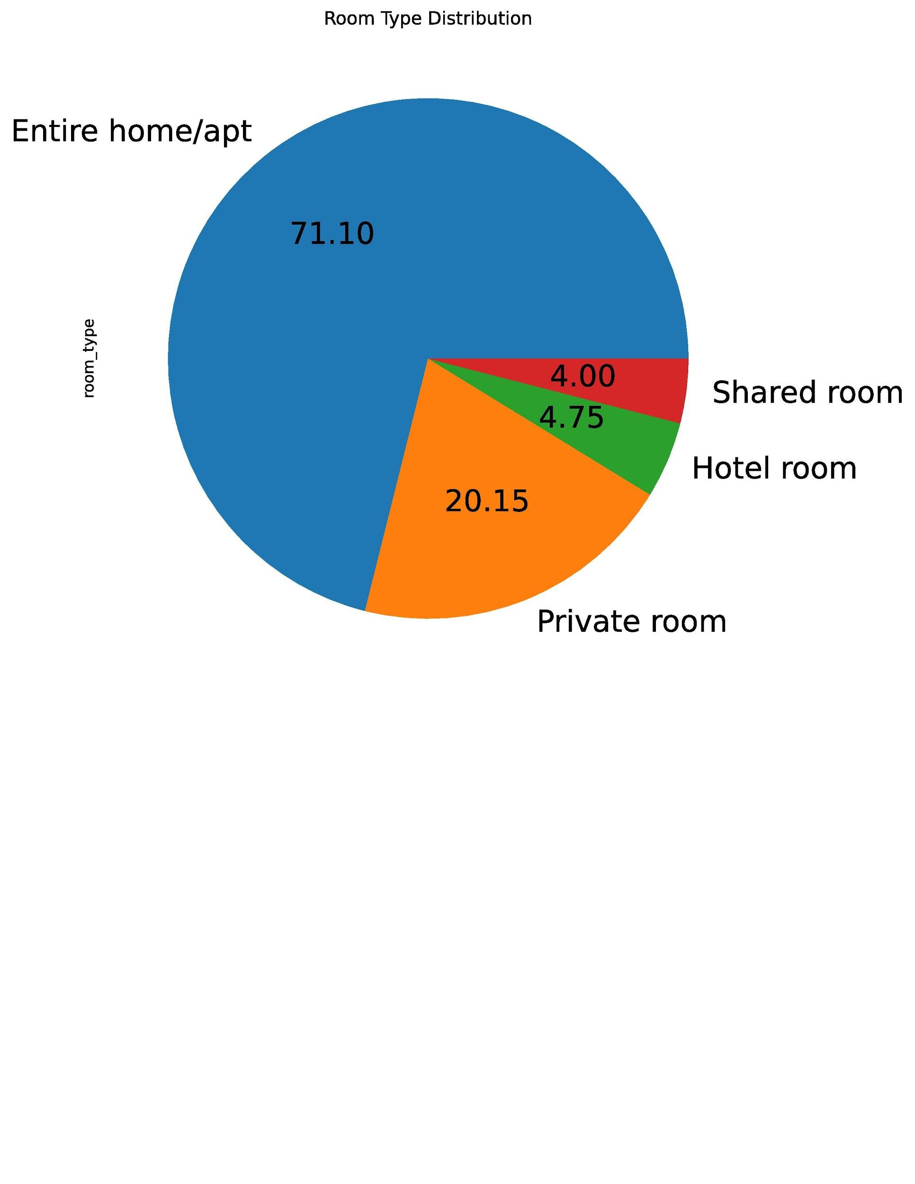

* 1. **Based on the plots and graphs above, there are several major factors that impact Tokyo’s Airbnb market and price**
     1. **Entire home/apt room type is the most prevalent at 71.1% of all listings, while private room follows at 20.15%.**
     2. **Airbnb Tokyo has more number of Entire home/apt, then followed by private rooms. Meanwhile, hotel rooms and shared rooms have lowest distribution at 4% and 4.75% respectively.**
     3. **The type of rooms impacts the price of listings tremendously. Entire hotels, room in boutique hotels, entire tent and entire villa are properties with maximum listing prices.**
     4. **Shared rooms typically have the lowest listing price. Shared rooms in tiny houses, guest houses, cabins, and dorms are properties with minimum listing prices.**
     5. **Prices of listings are dependent on the neighborhood of the property.** 
        1. **Neighborhoods such as Chiyoda Ku, Hachioji with entire house/apt, Taito Ku, and private rooms in Shibuya Ku have highest listing prices**
        2. **Akiruno Shi, Komae Shi, Tama Shi, and Tachikawa Shi have relatively low listing prices**
     6. **Due to densely populated conditions in Tokyo, apartments take up an overwhelmingly large proportion of listings, while houses take the second largest proportion.**

1. **Where to invest in Tokyo for maximum return on investment?**

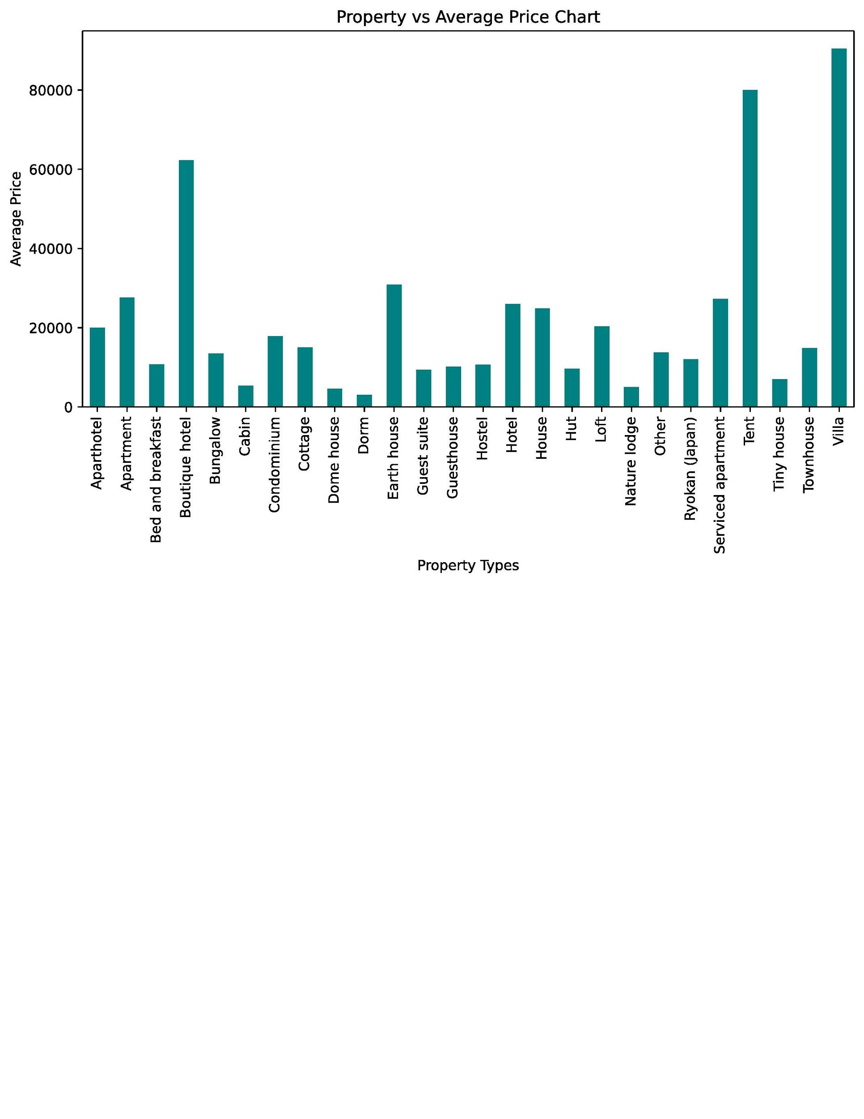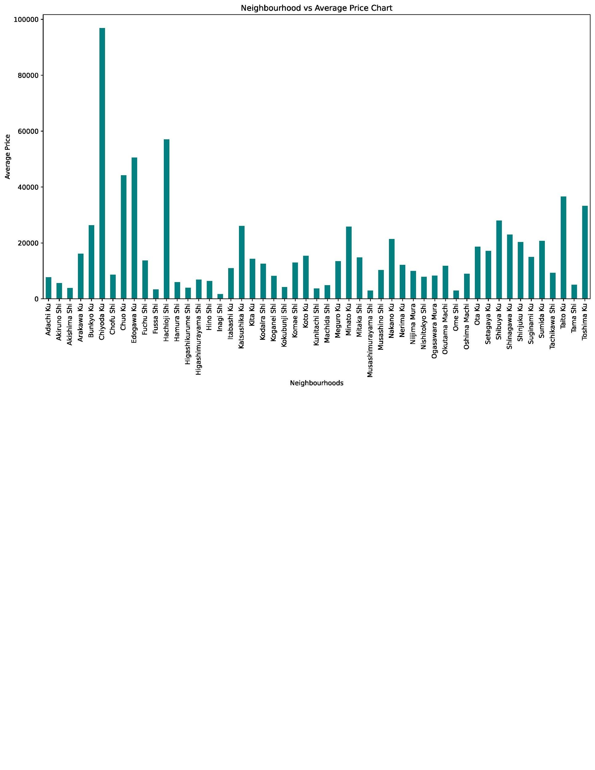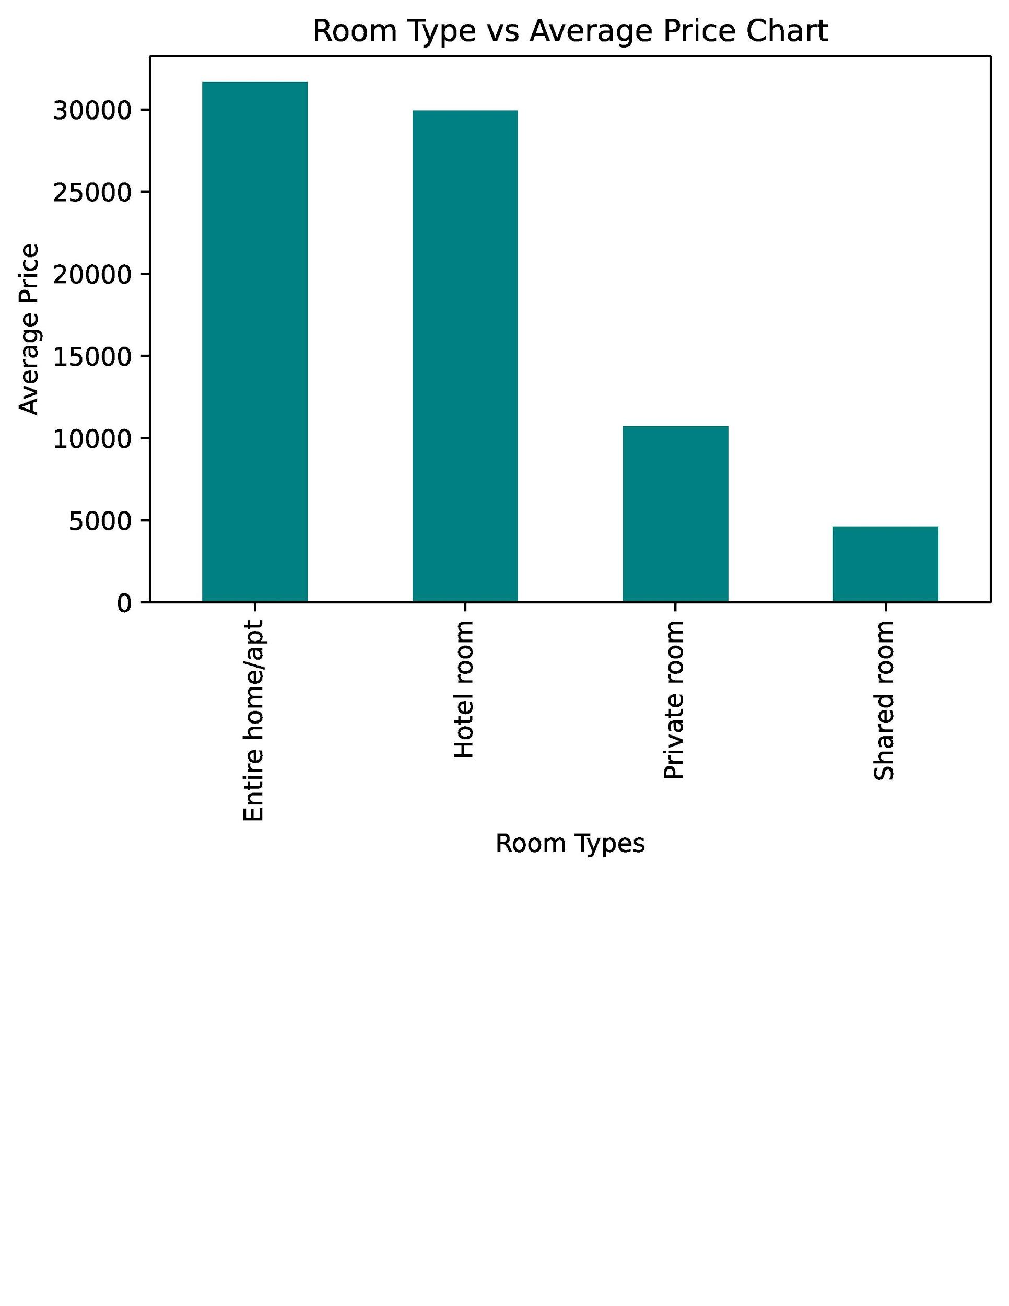

* 1. **Apparently, the average price of an entire home/apt is a lot higher than a private room and shared room. In order to generate more revenue, it will be more wise for Airbnb to list more entire homes and apartments due to larger portions of these types of listings and higher average price.**
  2. **Chiyoda Ku, Hachioji Shi, Edogawa Ku, Chuo Ku, Taito Ku, and Toshima Ku in order are six neighborhoods with the highest average listing price. Also, an entire home or apt in Chiyoda Ku can generate more hefty revenue than other neighborhood/room type combinations.**
  3. **Ome Ku, Inagi Shi, Musashimuyama Shi, Fusua Shi, Akishima Shi, Kunitachi Shi, and Machida shi are seven neighborhoods with particularly low average listing prices. High occupancy rates in these neighborhoods can generate revenue if Airbnb caters these listings to low budget travelers and student travelers with minimal budget.**
  4. **Boutique Hotels, Villas, and Tents generate the most expensive listing prices. Since these types of listings are few in number, they can only generate large revenues if someone is interested in investing or renting these types of properties.**
  5. **On the other hand, cabins, Dome Houses, Nature Lodges, and Dorm Rooms are best housing types to cater to low-budget travelers due to lowest average listing prices.**

1. **How can we correlate reviews and relationships with key variables?**

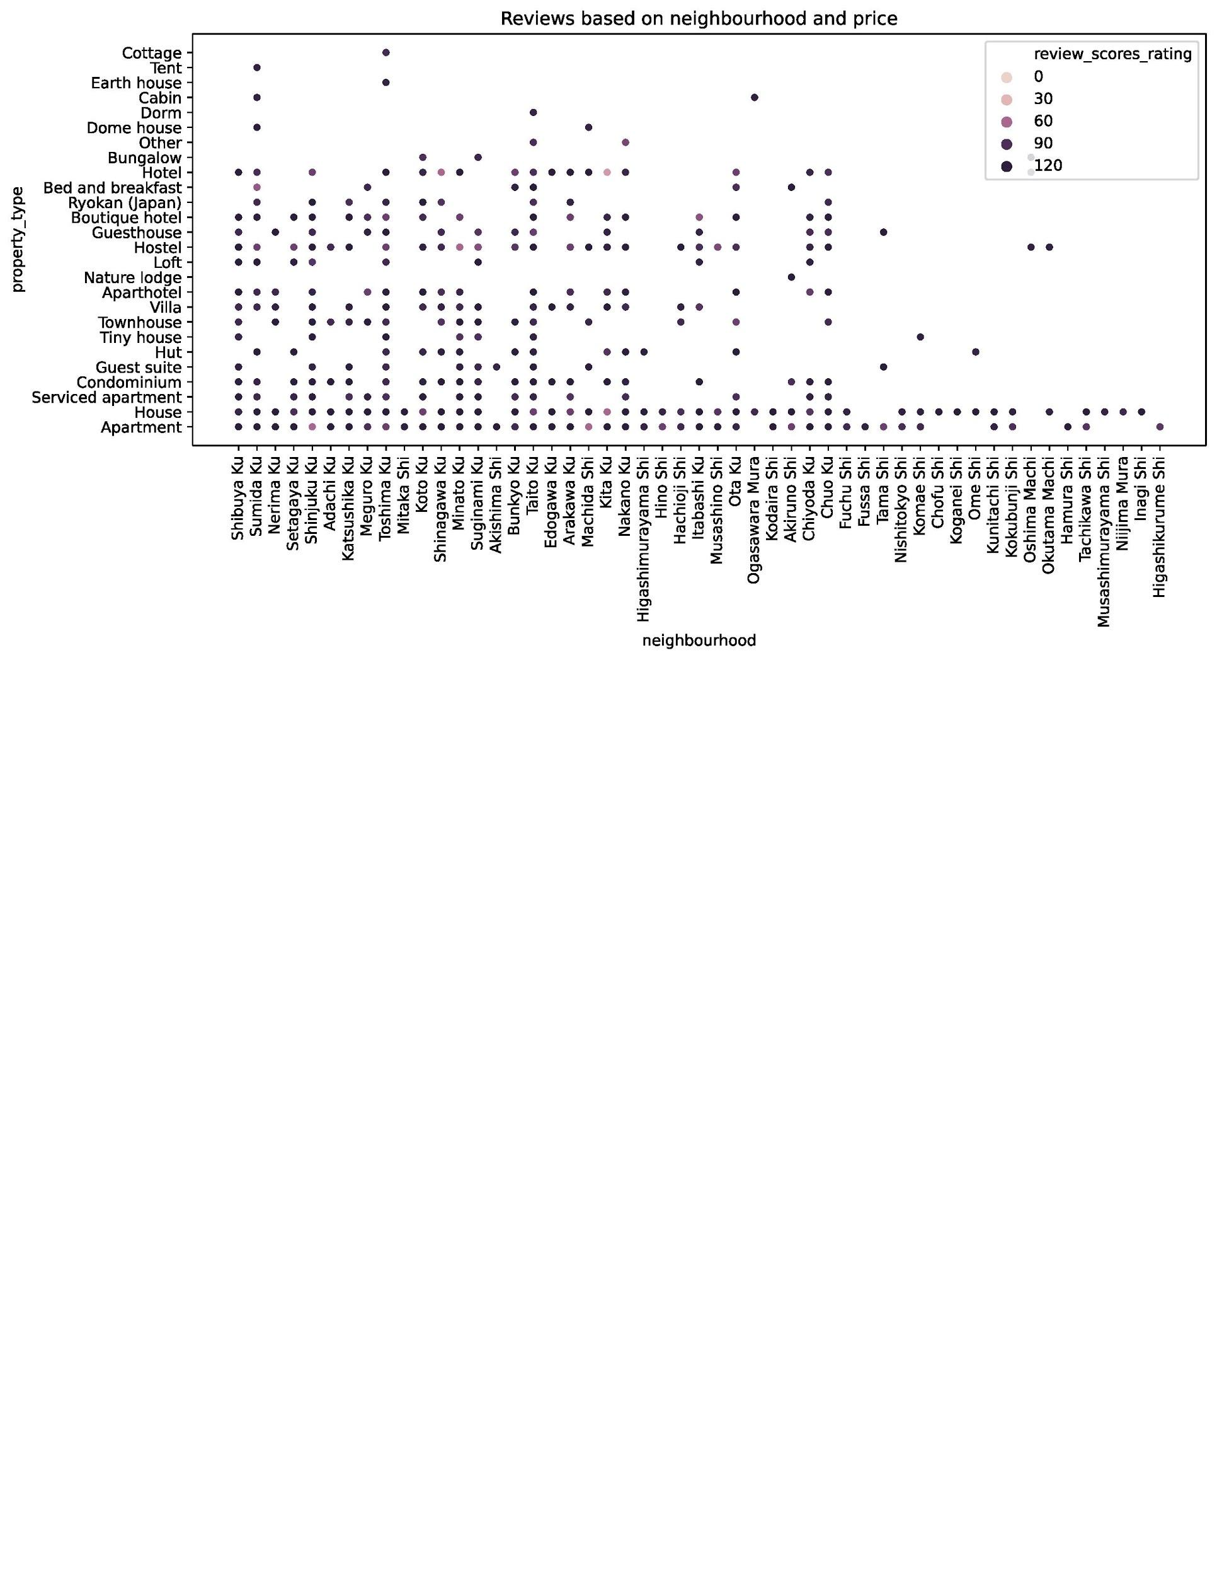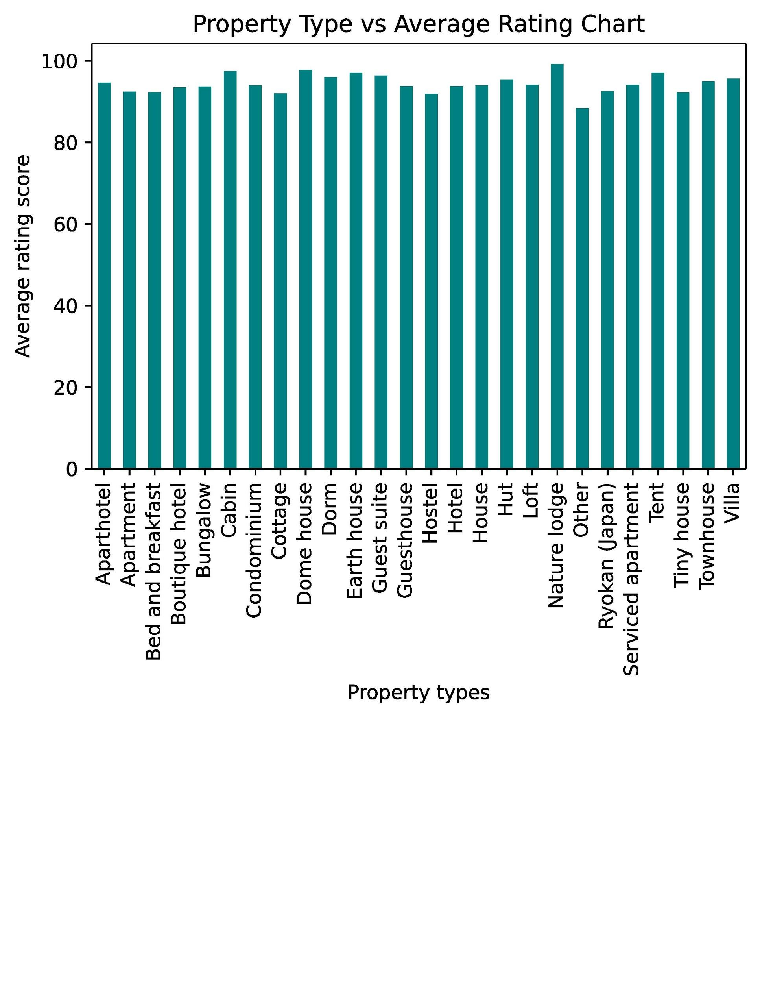

* 1. **On this data, it seems that people have particularly good experience in Nature lodges, Cabins, and Dome houses depending on their budgets and interests. Due to low average cost for these types of houses, these property types have a solid potential based on return on investment.**
  2. **Other property types and tiny houses have lowest average reviews. However, since all property types have average ratings above 80, there are no housing types that need special attention for poor average reviews in general.**
  3. **The types of neighborhoods and properties that have poor average reviews and need more attention are:**
     1. **Apartments in Shinjuku Ku**
     2. **Apartments in Tama Shi**
     3. **Houses and Hotels in Kita Ku**
     4. **Hotels in Shinagawa Ku**

1. **What is the actual correlation of either price or listing review with other key variables?**

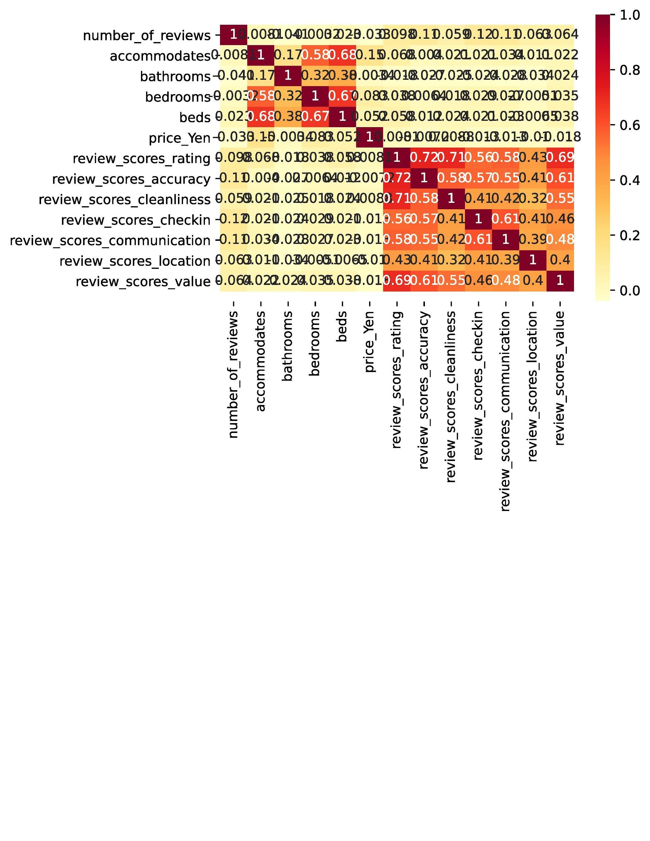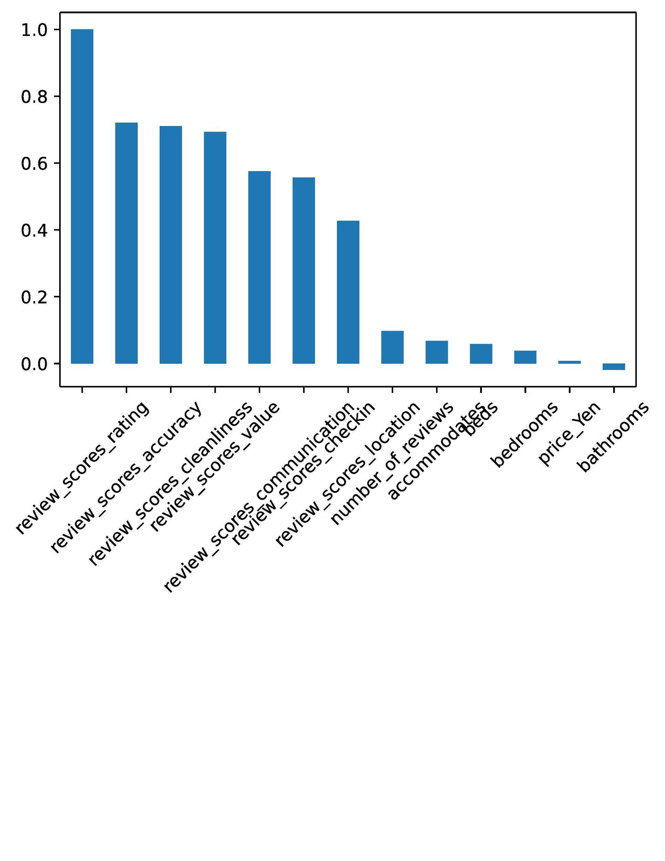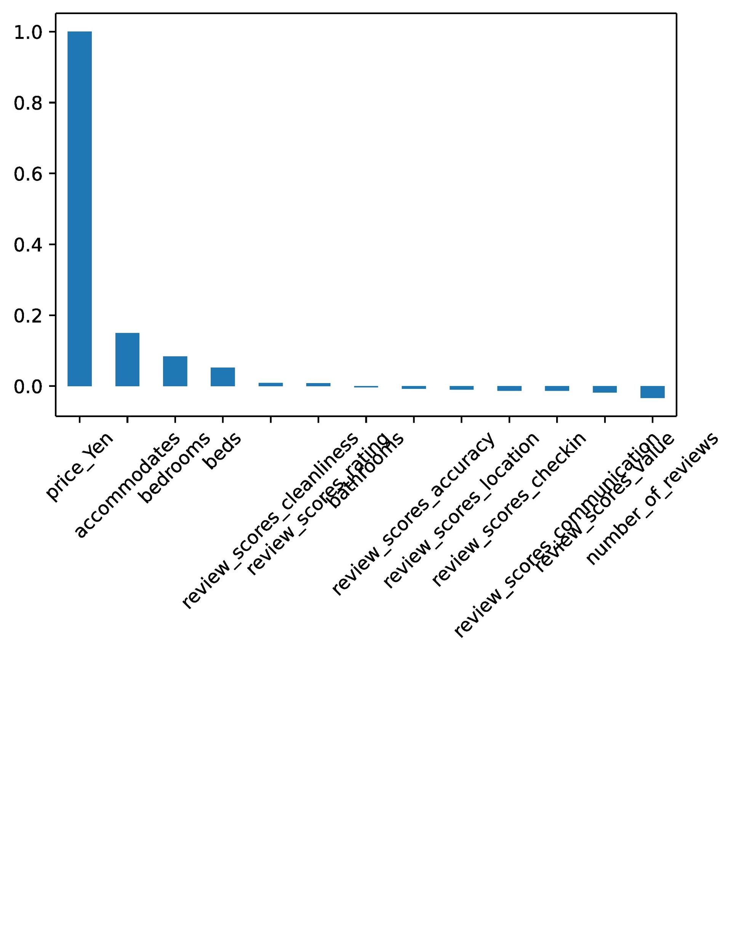

* 1. **Prices of the listing have little correlation with any other variables. The variables with highest correlations with listing prices are**
     1. **Accommodates: 0.15**
     2. **Bedrooms: 0.08**
     3. **Beds: 0.05**
  2. **Overall review ratings only have solid correlations with subcategories of review ratings. The subcategories are listed below as:**
     1. **Accuracy: 0.72**
     2. **Cleanliness: 0.71**
     3. **Value: 0.69**
     4. **Communication: 0.58**
     5. **Check-in: 0.56**
     6. **Location: 0.43**
  3. **Based on the correlations above, accuracy of service, cleanliness, and value of the lodging are most valued by customers**
  4. **On the other hand, all other subcategories have low correlation with overall lodging reviews. For instance, the variable other than review subcategories that has the highest correlation with overall reviews is number of reviews at 0.098.**